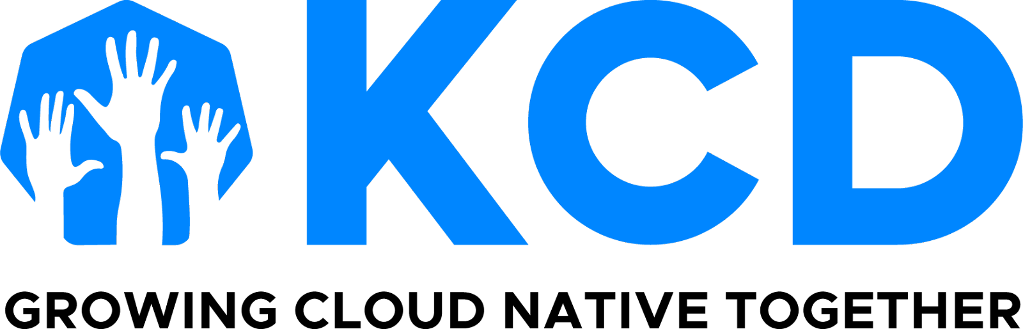

KCD Monthly Organizer Digest

September 6, 2024

## **Congratulations Taipei, Lahore, and Sydney!**

Congratulations to all teams that hosted KCDs in August and this first week of September!

We are excited for the next two KCDs happening in September:

* [KCD Washington DC](https://community.cncf.io/events/details/cncf-kcd-washington-dc-presents-kcd-washington-dc-2024/) on September 24 with DevOps days happening afterward
* [KCD Porto](https://community.cncf.io/events/details/cncf-kcd-porto-presents-kcd-porto-2024/) happening September 27 and 28 also with DevOps days happening after

**horizontal line**

UPCOMING DEADLINE

## **KCD 2.0 applications close in less than 6 days!**

Thank you for your submissions so far! If you have a partial response, don’t forget to go in and finish your submission.

| [**Apply Now**](https://www.cncf.io/kcds/application/) **for a 2025 KCD** |
| --- |

We wanted to provide some additional guidance on the following because we received questions in several feedback sessions with certain KCD groups.

**Further explanation of Terms & Conditions**

The KCD program is designed to help you run a great community event with CNCF support, and the terms of the program cover various areas to help you do so.

**Insurance**

We have received a few questions about the insurance requirements.

One can buy inexpensive event insurance online for small events. There are dozens of companies if you do a quick search. Anyone hosting an event should have insurance to protect themselves. However, your organization likely already has a general/umbrella policy that can be used for the event. Only folks newly starting an organization just to support KCDs would need to get new event insurance, and again this is super inexpensive.

Because the CNCF is supporting the event and its brands are used to promote the event, we ask to be listed as an additional insured party for the event on your policy. This is to protect both you and the CNCF.

**Centralized Registration**

We have had great success with our registration system for events all over the globe. We are not aware of any obstacles to KCD organizers using the same system, whether they be privacy- or tax-related, but if you have a concern, we are happy to address this on a case by case basis.

Like everything CNCF does, we aim to be vendor-neutral and a central supporter to these programs, and are here in partnership with you.

**horizontal line**

EXPLANATION

## **The KCD Organizer Slack Channel**

Some of you may or may not have noticed the notification I sent out on Friday about the perk/benefit of the KCD Organizer Slack channel in the CNCF workspace.

I want to apologize for not leaving it up for the weekend before cleaning up the channel before our Q2 was over.

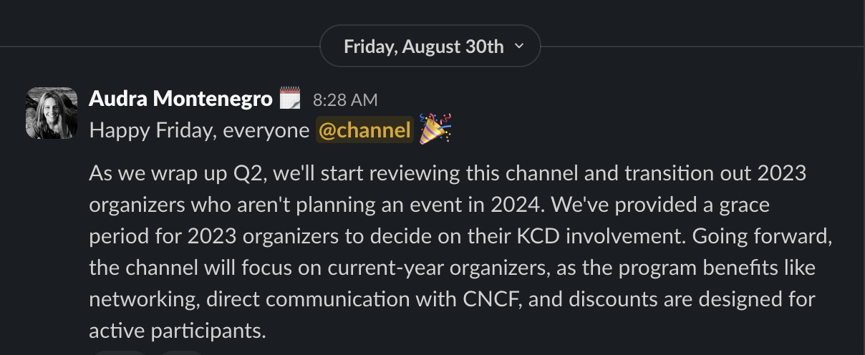

Again, my apologies for not being more considerate here. Please note that we will be doing the same with this email alias, and will replenish it with the 2025 organizers once acceptances and confirmations have gone out.

**horizontal line**

OPPORTUNITY

## **KubeCon + CloudNativeCon SLC Scholarships for KCDs**

Nominations for this scholarship closed on September 1, 2024 at 11:59pm Pacific Time, and notifications will be sent by September 16.

Please note that we had 7 responses, and a reminder that we can only send 3 people to KubeCon + CloudNativeCon in Salt Lake City. The criteria is as follows:

* You have not previously received attending a KubeCon + CloudNativeCon
* You will not been accepted via the [Dan Kohn scholarship this year](https://events.linuxfoundation.org/kubecon-cloudnativecon-north-america/attend/scholarships/)
* Your work cannot fund your travel

**horizontal line**

Thanks for your collaboration, feedback, and grace as the programs we produce grow. But most of all, thank you for helping make cloud native ubiquitous in your spare time.

Audra Montenegro

CNCF Community Program Manager

[**About KCDs**](https://www.cncf.io/kcds/) **|** [**KCDs GitHub Repository**](https://github.com/cncf/kubernetes-community-days/blob/main/README.md) **|** [**KCDs on Twitter**](https://twitter.com/KubernetesDays)

**US Time zone: Pacific**